Offer me water-I tend to ignore my thirst.

Tell me to get off of the couch, close the lap top, put down my phone.

Invite me to do things that are fun to get me away from the desk and out of the house.

Encourage me to share my ideas and then tell me to stop when I am over doing it.

I have a unique, creative, unconventional family that I don't spend enough time with.

I need to make physical activity a priority even though I am very drawn to lounging on the couch. I go to the Y at 5:30 am 3 days a week (and I am a night owl) At work I stand up at my desk.

Growing flowers and food is very important to me because I care about bees, birds, frogs and the planet.

I never liked living for the weekend or wishing away time but lately I really look forward to Friday!

I love to travel abroad or anywhere really and want to keep making this happen every few years.

I can keep calm under fire.

Thinking outside of the box is important to me. Sometimes I'm hesitant to share my 'crazy' ideas.

I am usually in good spirits and see the glass as half full.

I'm adventurous and a great traveler.

## HOW TO SUPPORT ME

## WHAT MATTERS TO ME

## LIKE AND ADMIRE

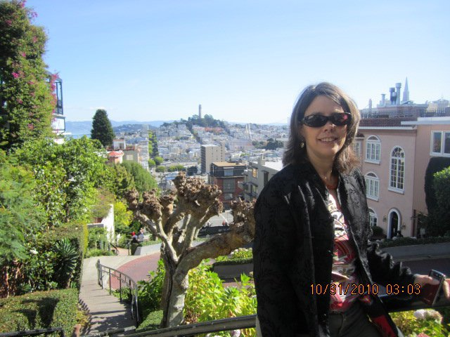

## SNAPSHOT