***Let’s find out and learn together.***

***There is no question that is a stupid question.***

***Experience is the best teacher.***

***Your “normal” and my “normal” may not be the same, but that doesn’t mean either of us are wrong.***

***Spending time with family and friends***

***Making memories as you never know when things can change.***

***Travel and new experiences are windows to the world.***

***Honesty is the best approach***

***Hard work and determination are admirable qualities.***

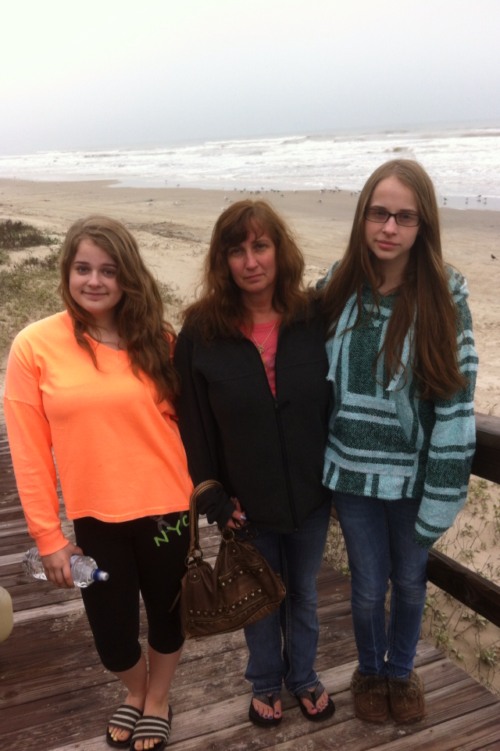

## HOW TO SUPPORT ME

## WHAT MATTERS TO ME

## LIKE AND ADMIRE

## SNAPSHOT